Police Officer

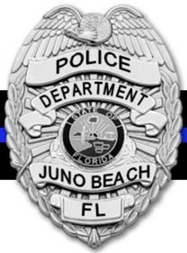

**Annual Wage:** $73,649 (based on 84-hour work period) - possible incentive for experience for two years full time experience

**Duties:** Perform general police work in the protection of life and property through the enforcement of laws and ordinances.

# Benefits:

# Florda Retirement System (FRS)

# Health, dental, vision, disability and life insurance

# Twelve (12) paid holidays

# Two hundred eight (208) hours of personal leave time for the first year

# Take home vehicle after FTO period

# Education and career training (assignment)

# Salary incentive

# Tuition Reimbursement

# Uniforms and equipment

# Uniform maintenance allowance

# _______________________________________________________________________________________

# Selection Process:

# Application Review

# Panel Review

# Oral Interview

# Computer Voice Stress Analysis (CVSA)

# Psychological Test(s) and Interview

# Medical Examination

# Background Investigation

# ________________________________________________________________________________________

**Basic Qualification Highlights:**

* No felony convictions
* No misdemeanor convictions involving “moral turpitude”
* Be a U.S. citizen
* Be at least eighteen (18) years of age
* Safe driving record
* Have a State of Florida Basic Law Enforcement Certification in good standing
* Out-of-state certified officers and federal officers must have at least one (1) complete year of full time police experience and complete the FDLE Equivalency of Training certification process

For additional questions, please contact the Juno Beach Police Department or Finance/HR Department. Please visit the Town of Juno Beach website for additional information about the Town.

Deliver the completed application to:

Town of Juno Beach Finance/HR Dept. 340 Ocean Drive

Juno Beach, Florida 33408

**Equal Opportunity Employer Drug and Tobacco Free Workplace**